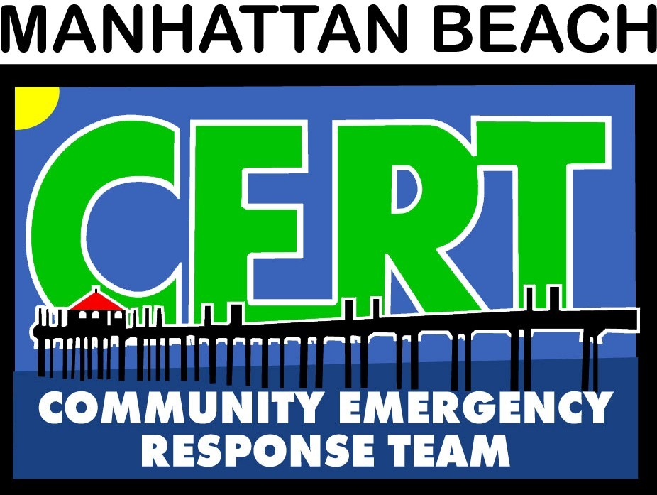
Emergency Preparedness
Training Class
Is offered by the
Manhattan Beach Community Emergency Response Team (CERT)
and the
Manhattan Beach Fire Department

Free for those who live or work in Manhattan Beach*.

Visit mbcerta.org for more information on what we have to offer.

Friday November 1, 2024 6 pm to 10 pm
Saturday November 2, 2024 8 am to 5 pm
Sunday November 3, 2024 8 am to 5 pm

The course consists of ALL 3 days of training.
Classes will be held at the MB Police/Fire Department Community Room off the plaza at 400 15th St.

Acquire or Brush-Up on LIFE SAVING Skills for You, your Family, Co-workers, & Neighbors

 Light FIRE FIGHTING Skills
RAPID ASSESSMENT to Save Multiple Lives Light SEARCH & RESCUE
FIRST AID & TRANSPORT
COMMUNICATING to Receive Help & SURVIVING until Help Arrives

*The MBFD will cover the cost for those who live or work in MB. We ask that you send a check for $60.00 payable to MBCERTA as a deposit to reserve your space in the class, along with your email address, street address and cell phone number. The check will be returned to you on completion of the class. The deposit is non-refundable if you do not attend the class. For non-residents, the cost is $60. The class is limited to 20 participants, age 18+. Registration is on a first-come, first-serve basis with priority for those who live or work in MB. For more information, email info@mbcerta.org. Please mail checks to: MBCERTA, c/o MB Fire Department, 400 15th Street, Manhattan Beach, CA 90266.

